TASK 6:
class Solution {
public void sortColors(int[] nums) {
int low = 0; // position for next 0
int mid = 0; // current index
int high = nums.length - 1; // position for next 2

while (mid <= high) {
if (nums[mid] == 0) {
swap(nums, low, mid);
low++;
mid++;
} else if (nums[mid] == 1) {
mid++;
} else { // nums[mid] == 2
swap(nums, mid, high);
high--;
}
}
}

private void swap(int[] nums, int i, int j) {
int temp = nums[i];
nums[i] = nums[j];
nums[j] = temp;
}
}

Case 1:
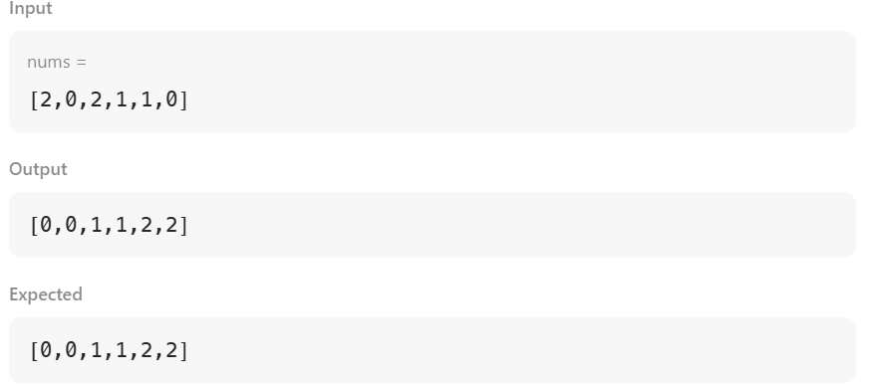
Case 2:
